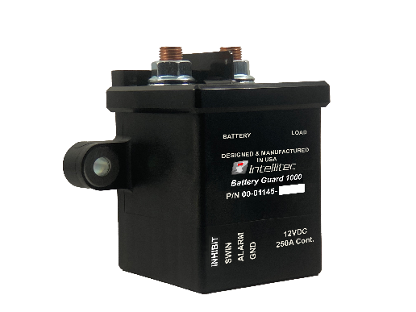Heavy Duty

Battery Guard® 1000 (12v)

Part number: 00-01145-000

Description:

The HD Battery Guard® 1000 helps prevent "dead batteries". By disconnecting the battery load from the battery before it becomes too discharged, the HD Battery Guard® 1000 protects the battery from potential damage. It is designed to be used in vehicles with 12-volt electrical systems. The Battery Guard® 1000 is an improved and simplified solution to the well-recognized Intellitec Battery Guard® line of products. This rugged, latching relay is capable of carrying heavy vehicle currents even though it requires no power to maintain its open or close positions. This single housing solution is easy to install and includes features such as automatic disconnect and reconnect, manual disconnect and reconnect, alarm output status and fault indication.

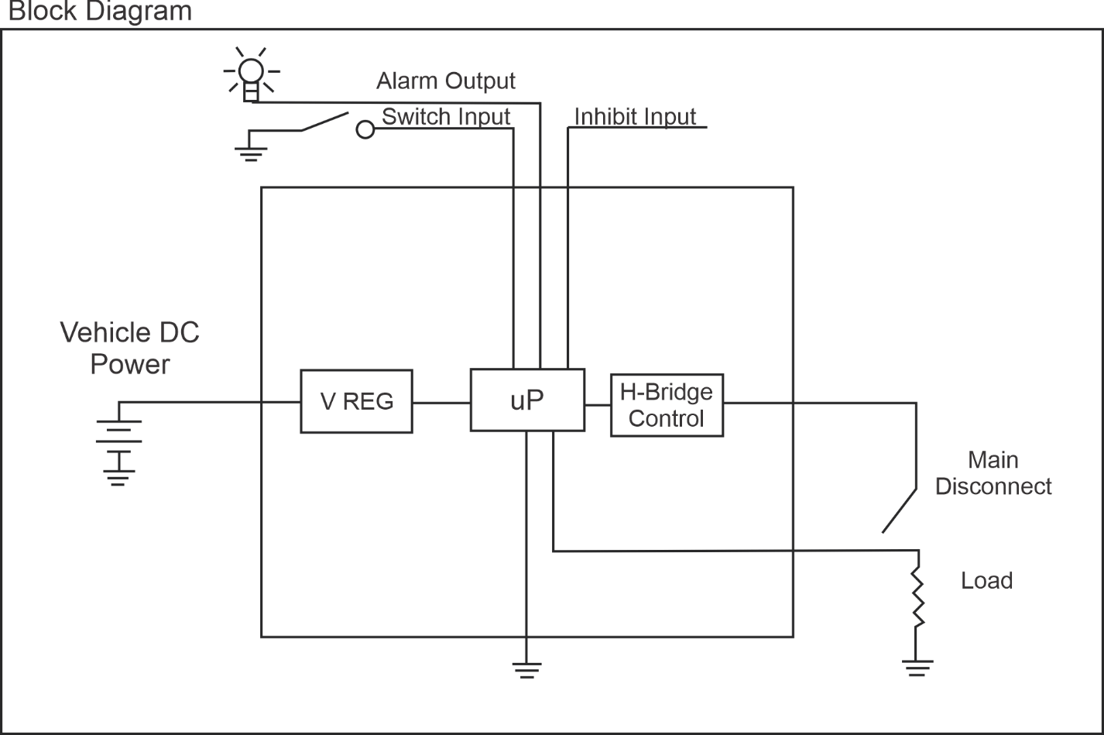

Product Features ____________________________________

* 250A continuous load capacity
* Magnetically latching requires no current draw to maintain
* Factory configurable parameters
* Automatic low voltage disconnect and charging voltage reconnect
* Disconnect and reconnect verification with automatic retry
* Momentary low-side switch input toggles between connected and disconnected state
* 300 mA high-side alarm output for indicating disconnected, reconnected and low voltage state
* Inhibit input signal prevents unwanted disconnects
* Quick Connect terminals for easy wire installation

Environmental Specifications_____________________________________________

Operating temp: -20/50 deg C (-24/122 deg F)

Storage temp: -40/85 deg C (-40/185 deg F)

Intrusion Rating: None

Electrical Specifications Unit Min Typ. Max

Operating supply voltage V 9 12 18

Reverse supply voltage V -30

Quiescent Current Draw mA 1 5

Mechanical Specifications Unit L x W x H

Housing: Inch 2.53 x 4.02 x 3.52

mm 64.26 x 102.11 x 89.41

Module Weight: oz 14.4

g 408.23

Available Accessory Items and Kits

250A HD Battery Guard® 1000 Kit: 10-01145-000

(Includes 00-01145-000, 11-01085-001, 11-01118-000, 11-01118-001)

Battery Guard® 1000 Reset Switch: 11-01085-001

Battery Guard® 1000 Harness Extension (10ft): 11-01118-000

Battery Guard® 1000 Harness (10ft): 11-01118-001

Available Product Literature and Guides:

Brochure: 53-01145-000

Product Specification: 53-01145-001

User’s Guide: 53-01145-100

Installation and Applications: 53-01145-200

Supporting Documents: 53-01145-300

Contact Information: www.intellitec.com

Intellitec Products, LLC 1485 Jacobs Road, De Land Florida, USA 32724

(386) 738-7307