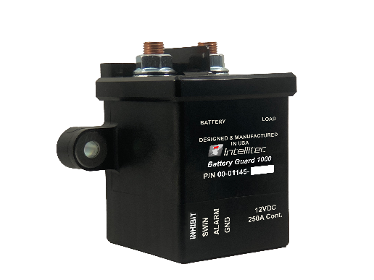
Heavy Duty
Battery Guard® 1000 (12v)
Part number: 00-01145-000

The HD Battery Guard® 1000 provides a solution for protecting your batteries from discharging to a level that might damage your batteries or to a level that prevents the vehicle from being started. The HD Battery Guard® 1000 constantly monitors the voltage level of the battery to determine the level of charge. When the voltage drops below the low voltage threshold for a specified duration of time, the HD Battery Guard® 1000 will automatically disconnect the battery from the system load, protecting the battery from excessive discharge.

If the HD Battery Guard 1000® senses a charging potential for a specified duration of time, then it will automatically reconnect the system load. This condition usually occurs when a charging device is connected to the battery, or the engine is running.

Connecting and Disconnecting the System Loads

The HD Battery Guard® 1000 accepts a momentary low side switch input signal. This switch allows the user control to manual disconnect or reconnect the system loads at the user’s discretion. Simply push and release the pushbutton and the HD Battery Guard® 1000 will switch states. Keep in mind, the device has a built-in state change delay of 5 seconds to prevent constant cycling of the disconnect.

Note: If the user chooses to disconnect the system manually, the HD Battery Guard® 1000 will not automatically reconnect if it senses charging.

Alarm indication

An alarm output is used to provide the user with valuable information about the state of the disconnect. This is a high side output alarm that is limited to 300 mA. When used with Intellitec’s Battery Guard Switch (11-01085-001), this output is tied to an LED indicator.

Solid On – Indicates that the system loads are connected, and the battery voltage is above the low voltage threshold.

Flashing at ½ Hz – Indicates that the system loads are connected, and the battery voltage is below the low voltage threshold.

Solid Off – Indicates that the system loads are disconnected.

Inhibit Input Signal

The inhibit input signal is a positive (Battery Voltage) signal that prevents the HD Battery Guard® 1000 from performing an automatic disconnect when in the connected state. This signal does not prevent manual disconnects from occurring and will allow the HD Battery Guard® 1000 to reconnect when a charging voltage is present.

Diagnostics

If the HD Battery Guard® 1000 fails to operate as intended, locate the device. The Battery Guard® 1000 provides a diagnostic LED on the module that indicates several failure modes.

1 Blink – Failed to disconnect
2 Blinks – Failed to reconnect
3 Blinks – Below minimum disconnect voltage.

This information can be very useful when trying to troubleshoot the HD Battery Guard® 1000. In the event that there is an issue, and the operator needs to bypass the disconnect. Remove the System load wire from the HD Battery Guard 1000 terminal and move it to the same side as the positive battery feed.

WARNING: Before performing this task, disconnect all sources of power. Unplug the coach and turn off the generator. Disconnect the battery(s) negative (-) terminal.
Operating Parameters

The table below defines the operating parameters used by the HD Battery Guard® 1000. The device comes with two sets of preconfigured parameters, one for chassis disconnects and one for coach disconnects. Depending on what mode the device is in, the parameters may vary.

ATTENTION: Intellitec part number 00-01145-000 is configured to the default parameters listed in the table below. Custom configurations recorded as 00-01145-XXX are configured to the customer’s parameters.

Parameter | Chassis Battery | Coach Battery
Low Voltage Disconnect Threshold | 12.1 Volts | 10.5 Volts
Isolation Delay | 5 Minutes | 3 Minutes
Minimum Disconnect Threshold | 9.0 Volts
Charging Voltage Threshold | 13.3 Volts
Reconnect Delay | 1 Minute
State Change Delay | 5 Seconds

Refer to the 53-01145-200 Installation Guide on how to switch between configurations.

Available Product Literature and Guides:
Brochure: 53-01145-000
Product Specification: 53-01145-001
User’s Guide: 53-01145-100
Installation and Applications: 53-01145-200
Supporting Documents: 53-01145-300

Contact Information: www.intellitec.com
Intellitec Products, LLC 1485 Jacobs Road, De Land Florida, USA 32724
(386) 738-7307

