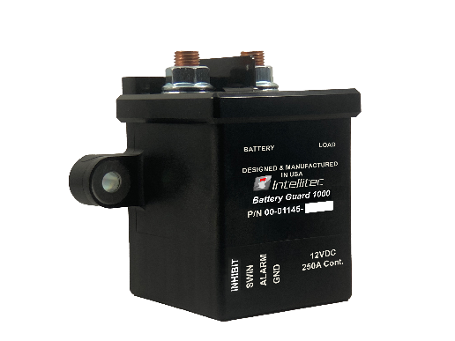Heavy Duty

Battery Guard® 1000 (12v)

Part number: 00-01145-000

|  |  |  |  |  |  |  |  |
| --- | --- | --- | --- | --- | --- | --- | --- |
| **Description** | **EEPROM** | **Size** | **Steps** | **Units** | **Default** | **Formula** | **Variable** |
| Low Chassis Voltage Threshold | 0x01 | 8 bit | 100 | mV | 121 | 121*100mV = 12.1V | LowVoltageThresholdCal |
| Isolation Chassis Delay | 0x02 | 8 bit | 10 | S | 30 | 30*10 = 300 S | IsolationDelayCal |
| Verification Retry | 0x03 | 8 bit | 1 | Counts | 3 | N/A | VerificationRetryCtCal |
| Minimum Voltage Threshold | 0x04 | 8 bit | 100 | mV | 90 | 90*100mV = 9.0V | MinimumVoltageThresholdCal |
| Charging Voltage Threshold | 0x05 | 8 bit | 100 | mV | 133 | 133*100mV = 13.3V | CharingVoltageThresholdCal |
| Charging Reconnect Delay | 0x06 | 8 bit | 10 | S | 6 | 6*10S = 1 minute | ChargingReconnectDelayCal |
| Reconnect Retry Attempts | 0x07 | 8 bit | 1 | Counts | 3 | N/A | ChargingVerificationRetryCal |
| State Change Delay | 0x08 | 8 bit | 1 | S | 5 | 5*1S= 5S | SwitchInputDelayCal |
| Coil Pulse Width | 0x09 | 8 bit | 10 | mS | 30 | 30*10mS=300mS | CoilPulseWidthOutputCal |
| PCB LED Blink On Time | 0x0A | 8 bit | 10 | mS | 30 | 30*10mS=300mS | LEDOnCal |
| PCB LED Blink Off Time | 0x0B | 8 bit | 10 | mS | 30 | 30*10mS=300mS | LedOffCal |
| PCB LED Blink Pause Time | 0x0C | 8 bit | 10 | mS | 20 | 20*20mS=200mS | LedPauseCal |
| Contact State Feedback Delay | 0x0D | 8 bit | 1 | S | 3 | 3*1S=3S | ContactStateDelayCal |
| Allowed Drop Across Contact | 0x0E | 8 bit | 100 | mV | 3 | 3*100mv=300mV | AllowedVoltageDropCal |
| Allowed Disconnect Voltage | 0x0F | 8 bit | 1 | Divider | 2 | VBAT / 2 | AllowedDisconnectVoltageDivider |
| Connected Voltage Samples | 0x10 | 8 bit | 1 | Counts | 10 | N/A | ConnectedVoltageSamplesCal |
| Battery Voltage Samples | 0x11 | 8 bit | 1 | Counts | 10 | N/A | BatteryVoltageSamplesCal |
| Alarm LED Flash Time | 0x12 | 8 bit | 10 | mS | 50 | 50*10mS =500mS. | LEDBeatCal |
| Alarm LED Wink On Time | 0x13 | 8 bit | 10 | mS | 10 | 10*10mS = 100mS | WinkHighCtrCal |
| ALARM LED Wink Off Time | 0x14 | 8 bit | 100 | mS | 30 | 30*100mS = 3Sec | WinkLowCtrCal |
| Isolation Reentry Time | 0x15 | 8 bit | 1 | S | 30 | 3 *1S = 30sec | IsolationReentryCal |
| Low Coach Voltage Threshold | 0x16 | 8 bit | 100 | mV | 105 | 105*100mV=10.5V | LowVoltageThresholdCal |
| Isolation Coach Delay | 0x17 | 8 bit | 10 | S | 18 | 18*10 = 180 Seconds | IsolationDelayCal |
| Low Threshold Mode | 0x30 | 8 bit | 2 | Counts | 0 | 0 = Chassis, 1 = Coach | LowvMode |

Available Product Literature and Guides:

Brochure: 53-01145-000

Product Specification: 53-01145-001

User’s Guide: 53-01145-100

Installation and Applications: 53-01145-200

Supporting Documents: 53-01145-300

Contact Information: www.intellitec.com

Intellitec Products, LLC 1485 Jacobs Road, De Land Florida, USA 32724

(386) 738-7307